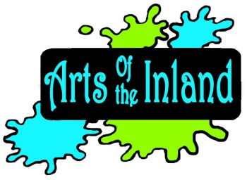ARTS OF THE INLAND -- SPONSORSHIP
ARTS OF THE INLAND is a public charity, 501(c)(3) not-for-profit organization.

Mission Statement: The mission of Arts of the Inland (AOI) is to facilitate and nurture the creation, development, promotion and education of arts and culture in the inland communities of south Florida.

Sponsors will be recognized with your logo & a link on our website and in all event publicity and news releases. To become a sponsor, please fill out the following form and return with your generous contribution:

Date
New Sponsor_
Sponsor Renewal

Organization Name_

Contact Individual

Address_

City _State Zip Code_

Telephone_

E-Mail Web Site:

SPONSOR LEVEL

$ 150.00

$ 250.00

$ 500.00

Other $

We thank you for your consideration and your commitment to help us accomplish our mission.

Make check payable to Arts of the Inland, and give it to your AOI REPRESENTATIVE or send to Arts of the Inland, P.O. Box 573, Lehigh Acres, FL 33970 or use PayPal at our website: www.artsoftheinland.com.

> > For Arts of the Inland Use Only < <

Check: $ Received: By:
Number Dated Amount Date

